TAbleau Project

C Program

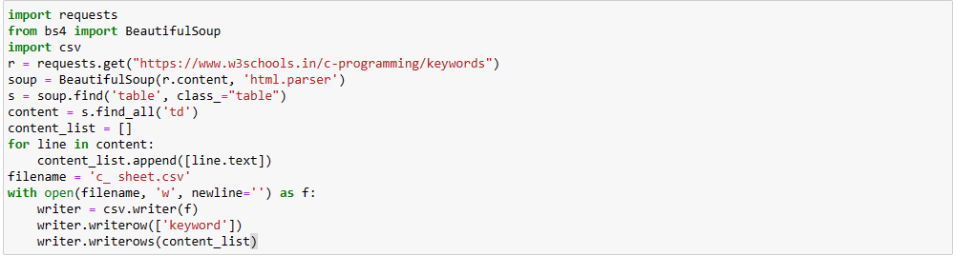

C++ Program

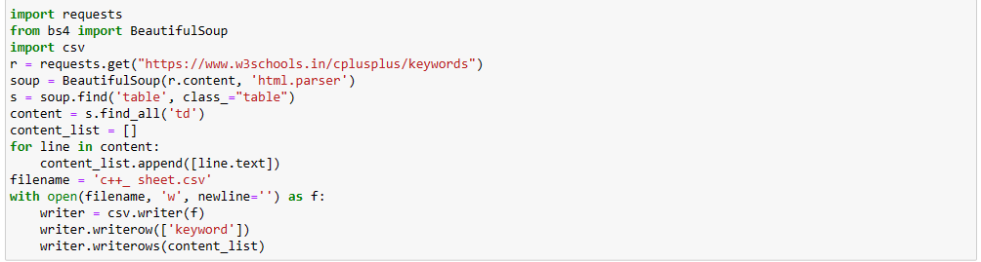

Python

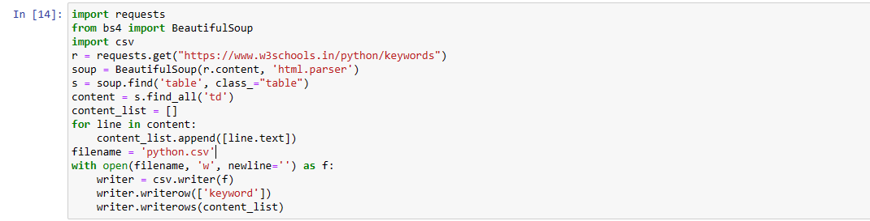

SQL

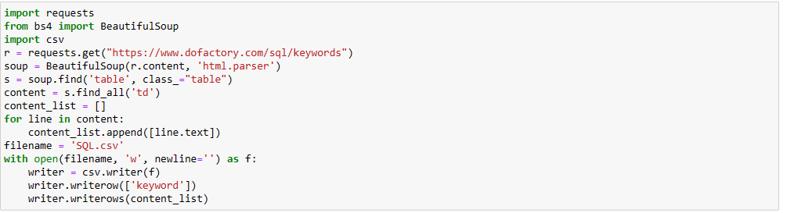

Java

